High Level Use Case Diagram

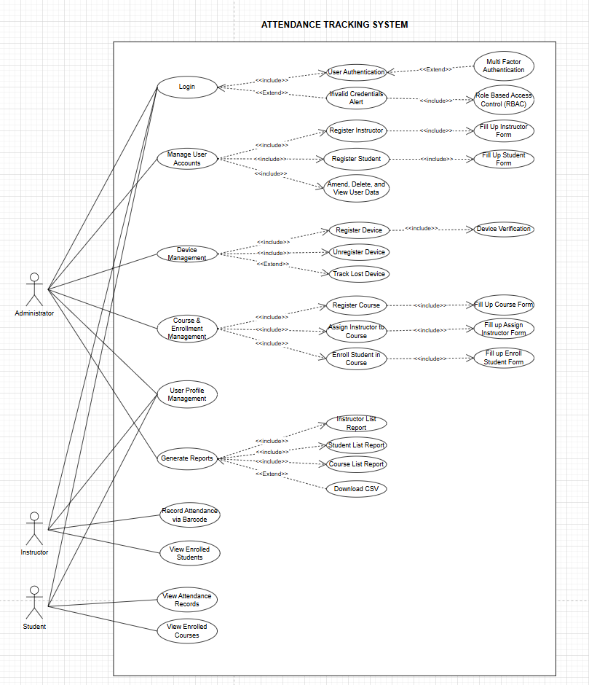Jak of all Trades